Architecture Design (AD)

Entertainer Data Analysis

Last date of revision: 24/05/2024

Divakar K G

[AUTHOR NAME] 1

**Document Version Control**

**Date Issued**

**Version**

**Description**

**Author**

**24th May 2024**

1.0

First Version of Complete AD

Divakar K G



[AUTHOR

**Contents**

1. Introduction 4

1.1 What is Architecture design document? 4

1.2 Scope 4

2. Architecture 5

2.1 PowerBI Architecture 5

2.2 Components of PowerBI architecture 5

3. Deployment 8

3.1 PowerBI Deployment 8

3.3.2 Publishing report to PowerBI services 8

[AUTHOR NAME]



**1 Introduction**

**1.1 What is Architecture design document?**

Any software needs the architectural design to represents the design of software. IEEE defines architectural design as “the process of defining a collection of hardware and software components and their interfaces to establish the framework for the development of a computer system.” The software that is built for computer-based systems can exhibit one of these many architectures.

Each style will describe a system category that consists of :

* A set of components (eg: a database, computational modules) that will perform a function required by the system.
* The set of connectors will help in coordination, communication, and cooperation between the components.
* Conditions that how components can be integrated to form the system.
* Semantic models that help the designer to understand the overall properties of the system.

**1.2 Scope**

Architecture Design Document (ADD) is an architecture design process that follows a step-by step refinement process. The process can be used for designing data structures, required software architecture, source code and ultimately, performance algorithms. Overall, the design principles may be defined during requirement analysis and then refined during architectural design work.

**2. Architecture**

**2.1 Power BI Architecture**

Power BI is a powerful business analytics service by Microsoft that enables users to visualize and share insights from their data. Its architecture is designed to provide a seamless flow of data from various sources to interactive dashboards and reports. The core components of Power BI architecture include:

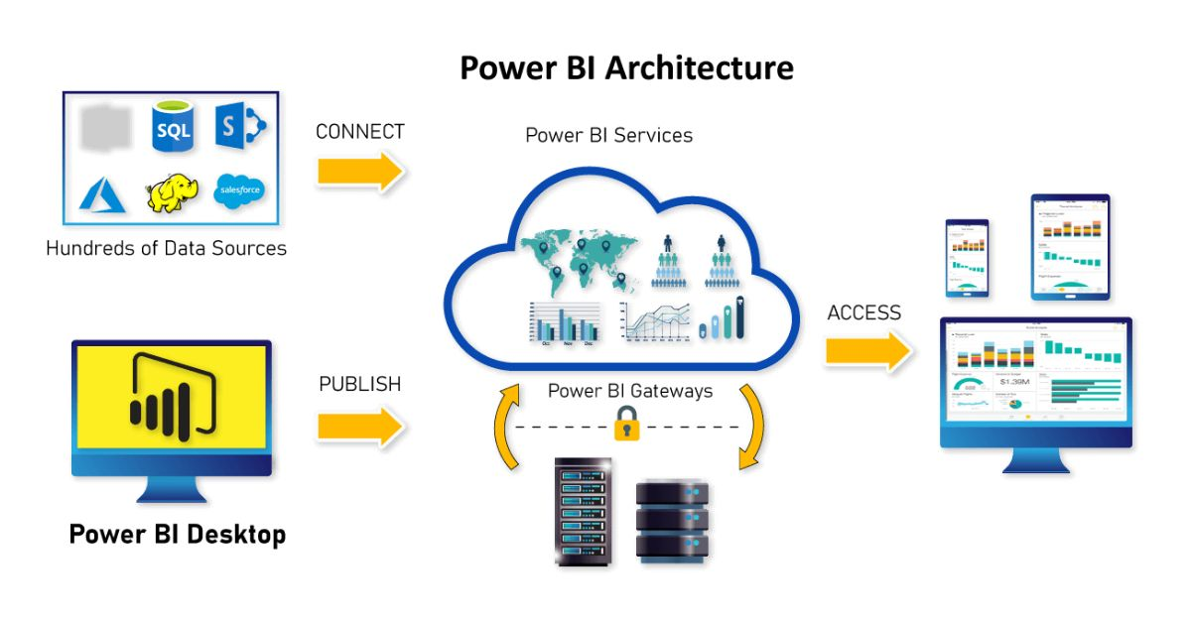

**2.2 Components of PowerBI architecture**

**1.Data Sources**

One can connect to a wide variety of data sources to ingest data for analysis and reporting. Using Power BI. This includes both on-premises and cloud data sources like:

Excel and CSV files

SQL Server databases

Azure data services like Azure SQL Database

Software as a service (SaaS) applications like Salesforce, Google Analytics, etc.

With over 100 native connectors, Power BI can connect to data wherever it resides. Both static and real-time data sources are supported.

**2. Power BI Desktop**

Power BI Desktop is a free, standalone desktop application that enables data transformation, modeling, visualization and report creation capabilities.

With Power BI Desktop, users can:

Connect to data sources and import data

Transform, clean and restructure data as needed

Model and analyze data by creating relationships and calculations

Design interactive reports with various visualizations like charts,

maps, widgets, etc.

Publish reports and datasets to the Power BI Service to share with

others

It provides a self-service BI experience through an intuitive drag-and

drop interface without needing IT involvement.

**3. Power BI Service**

The Power BI Service is a SaaS platform to collaborate, publish, manage and distribute reports and dashboards. User-created content from Power BI Desktop can be uploaded here.

Key capabilities offered by the Power BI Service include:

Sharing interactive dashboards and reports with others in an

organization

Discussing data through comments and annotations

Publishing customized datasets and reports to the entire organization

Automatically refreshing reports with the latest data

Controlling access and permissions as per security policies

Monitoring usage metrics and audit logs

Integrating content into apps and third-party applications

It is the central hub where all end users can access and interact with Power BI content through a web browser or mobile app.

**4. Power BI Mobile Apps**

To enable the consumption of analytics on the go, Power BI provides native mobile apps for iOS, Android and Windows. These mobile apps allow easy access to Power BI dashboards and reports from mobile devices. Key features include dashboards optimized for smaller displays, push notifications on data updates, and offline access using cache, among others.

**5. Power BI Gateway**

This is an optional on-premises data gateway required if the data source is within a private network and needs to be kept completely secure.The gateway acts as a bridge to enable communication between on-premises data sources and the Power BI Service in the cloud. It provides controlled data access without exposing data on the open internet. Microsoft provides two types of gateways:

1. Personal gateway

2. Enterprise gateway

**6. Power BI Embedded**

For developers and ISVs, Power BI provides embeddable visuals using JavaScript APIs and Software Development Kits (SDKs). These can be used to embed rich Power BI visualizations within custom web and mobile applications.

1. **Deployment**

**3.1 PowerBI Deployment**

The deployment process lets you clone content from one stage in the pipeline to another, typically from development to test, and from test to production.

During deployment, Power BI copies the content from the current stage, into the target one. The connections between the copied items are kept during the copy process. Power BI also applies the configured deployment rules to the updated content in the target stage. Deploying content may take a while, depending on the number of items being deployed. During this time, you can navigate to other pages in the Power BI portal, but you can't use the content in the target stage.

**3.2 Publishing report to Power BI services**

To publish a report to Power BI service, first ensure your report is complete in Power BI Desktop, including visuals, data relationships, and any necessary calculations.

Sign in to the Power BI service, navigate to the desired workspace, and upload your report (.pbix file).

Review the report to confirm its accuracy, then publish it to the workspace. Share the report by granting access to the workspace or sharing a direct link. For reports with live or direct query connections, set up scheduled data refresh to maintain updated data. This ensures your report reflects the latest information from your data sources.